The SYSLOG consists of the following:

* All messages issued through Write To Log (WTL) macros.
* All messages entered by the LOG operator commands.
* Usually, the hardcopy log (console messages).
* Any messages routed to the SYSLOG from any system component or program.

**z/OS Format of the Message Body**

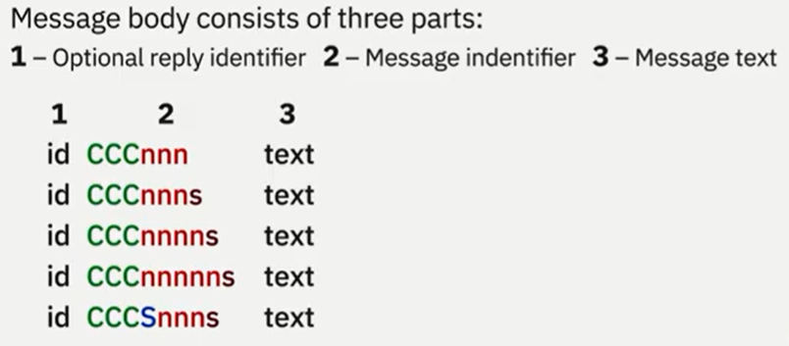

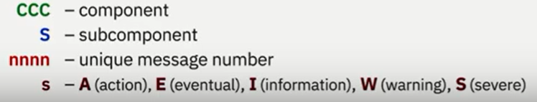

Example:

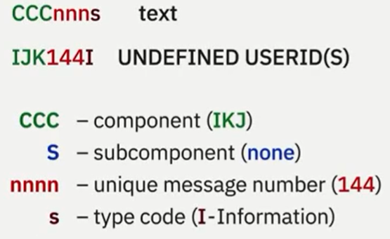

A unique prefix is assigned to each component. (IJK -> TSO)

Each SYSLOG entry has the following format:

**tcrrrrrrr sysname yyddd hh:mm:ss.th ident msgflags message**

**t message**

**t lid message**

**t ->** record type (single line, multiple line, or reply line)

* N - single-line message
* W - single-line message with reply
  + WTOR messages are not processed by Message Flood Automation.
* M - first line of a multi-line message
  + Message Flood Automation can only react to the first line of a multiline message, not to any of the label, data or end lines
* L - multi-line message label line
* D - multi-line message data line
* E - multi-line message data/end line
* S - continuation of previous line
* O - LOG command input
* X - non-hardcopy or LOG command source

**c ->** system command (input, response, or internal)

* C - command issued by operator
* R - command response message
* I - internally issued command
* U - command from unknown console ID

**rrrrrrr ->** routing code for console messages

Example:



**sysname ->**  the system name from the SYSNAME parameter in parmlib

**yyddd**  **->** the Julian date

**hh:mm:ss.th ->** time stamp

**ident ->** the job identifier for the task that issued the message, if the second character on the line is blank

If the second character on the line is C or R, this field contains one of the following:

**jobid**

The job identifier of the task that issued the message, if it was issued by a job.

**consname**

Console name of the console which issued the command or received the message.

**INTERNAL**

For a command generated by a problem program or the system.

**INSTREAM**

For a command read from the input stream.

**blank**

If MCS could not determine the source or destination for the message.

**lid ->** multiple-line identifier for the second and succeeding lines of a multiple-line message

**msgflags ->** installation exit and message suppression flags

**message ->** reply identifier, message identifier, and text

The reply identifier and message identifier appear only on the first line of a multiple-line message

Example:

